**Cellular Automaton Model**

问与答

1. 用元胞自动机模拟蚯蚓运动可以给我们带来什么?

通过设置一系列模型构建规则，元胞自动机可以以一定概率自动模拟物质的扩散，我们希望通过元胞自动机模拟蚯蚓在土壤中的运动，蚯蚓通过运动可以分散到土地各处，元胞自动机可以记录蚯蚓的位置，蚯蚓遍布的范围将关系蚯蚓处理铅效果。

1. 什么因素吸引蚯蚓运动？

蚯蚓的运动很容易受到环境的影响。根据湿度、有机质含量、地理特征和该处蚯蚓实时数量等因素对耕地进行吸引力划分。其中，蚯蚓实时数量对吸引力是反作用的。这样一来，吸引力将成为蚯蚓运动的关键，蚯蚓的轨迹可以预测。

1. 如何将蚯蚓运动和净化土壤铅离子结合？

每只蚯蚓都具有一定的处理铅的能力，这个能力来源于其携带的工程菌（经过改造的枯草芽孢杆菌）。在进行模拟前，我们将量化蚯蚓处理铅的能力，蚯蚓每次进食都会应用这种能力处理铅，而蚯蚓每次运动都在扩大这种能力应用的范围。

**Q&A**

**1. What can Cellular Automaton bring us ?**

By setting up a series of rules, Cellular Automata can automatically simulate material diffusion at a certain probability. We hope to use Cellular Automata to simulate earthworms movement. When they spread throughout the land by moving, Cellular Automata can record their locations, which are related to the soil lead purification.

**2.** **What can make earthworms move?**

The movement of earthworms is easily affected by the environment. We gave different attractions to different locations according to the factors such as humidity, organic matter content, geographical features and the real-time number of earthworms. Among them, the real-time number of earthworms is counter-acting to the attraction. In this way, attraction will be the key to the earthworm's movement, and earthworm's trajectory could be predicted.

**3. How to combine earthworm movement with soil lead purification?**

Every earthworm has some ability to deal with lead, which comes from the engineered bacteria (Bacillus Subtilis) that it carries. Prior to the simulation, we will quantify the ability. Every time they eat they would use the ability, and every time they move they would expand the application of the ability.

美工动图

**1 摘要**

本项目的目标是通过释放携带重新设计的枯草芽孢杆菌的蚯蚓来处理土壤铅污染问题。为了指导实验，提出最佳蚯蚓释放策略，我们构建了一个**Cellular Automaton**模型以获取不同策略的效果。基于模型机制，它可以拓展为处理世界不同地区的耕地铅污染问题。本文对不同的释放策略进行定性分析，给出了一些一般的结果和相对较好的释放策略。在最佳策略下，一次释放的蚯蚓数量应为，释放地点之间的间隔应大约为 米。这样，我们可以以最快的速度将目标耕地处理干净。

**1 ABSTRACT**

Our project is to address soil lead contamination by releasing earthworms carrying the redesigned *Bacillus subtilis*. To guide experiments and propose optimal earthworm release strategies, we constructed the Cellular Automaton Model to obtain the effects of different strategies. Based on the model mechanism, it could be used to deal with lead pollution of cultivated land in different regions of the world. In this paper, different release strategies are analyzed qualitatively, and some general results and release strategies are given. Under the best strategy, the number of earthworms to be released at a time should be about 1000 metres apart. In this way, we can clean the target farmland with the fastest speed.

**2 模型假设**

1. 在蚯蚓处理土壤铅污染期间不考虑蚯蚓死亡率
2. 由于地形不同等因素，对不同地区元胞设置不同吸引力
3. 间隔投放方式显然优于集中投放，模型中只寻求最佳间隔投放蚯蚓方案
4. 蚯蚓一天活跃时间为8小时，并认为该时间段内蚯蚓一直处于进食状态

**2 MODEL ASSUMPTIONS**

1. Earthworm mortality is not considered during the soil lead purification.
2. Due to different terrains and other factors, each cell has different attractions.
3. Interval feeding is obviously better than centralized feeding, and we only search for the best interval earthworm feeding scheme.
4. The active time of earthworms is 8 hours in a day, and it is believed that earthworms are always eating during this time.

**3 模型建立**

**3.1 元胞自动机简介**

通过设置一系列模型构建规则，细胞自动机[[1]](https://2019.igem.org/Team:NAU-CHINA/CA_Model" \l "i4)可以以一定概率自动模拟物质的扩散。在动态系统中，细胞自动机可以分为“均匀，周期性和混沌结构”三种类型。考虑到蚯蚓活动的聚集和周期性以及地形引起的边界条件的复杂性，具有周期性结构的细胞自动机明显优越。在算法复杂度和准确性方面，元胞自动机的性能也优于偏微分方程。

**3 MODEL**

**3.1 INTRODUCTION TO CELLULAR AUTOMATON:**

By setting a series of model construction rules, the Cellular Automaton[[1]](https://2019.igem.org/Team:NAU-CHINA/CA_Model#i4) can automatically simulate the diffusion of substances with a certain probability. In the dynamic system, Cellular Automaton can be divided into“homogeneous, periodic and chaotic structure”three types. In consideration of the aggregation and periodicity of insect activity and the complexity of boundary conditions caused by topography, the Cellular Automaton with periodic structure is obviously superior. In terms of algorithm complexity and accuracy, the Cellular Automaton also performs better than the partial differential equation.

**3.2 建立环境地图**

考虑到蚯蚓活动的范围和地形特征，我们将蜂窝大小设置为500 m×500 m。此外，考虑到有效范围，我们将元胞数设置为100×100，因此，整个环境地图代表一个覆盖2500平方公里的正方形地区。

考虑到蚯蚓活动易受到土壤条件、有机物质等的影响，我们应用矩阵简化了地形图，并根据地形特点和土壤条件对地图进行了吸引力划分。由于很难获得准确的地形图，因此我们使用根据x市的地形特征以及目标耕地的有机质分布情况随机生成地图。然后将地图简化为100×100的（0,95）矩阵其中95表示最高吸引力区域，0表示最低吸引力区域。该矩阵如下图3.2.1所示。

**3.2 BULIDING AN ENVIRONMENTAL MAP**

Due to the range of earthworm activities and topographic features, we set the size of the hive at 500 m×500 m. In addition, considering the effective range, we set the number of cells to 100×100, so the entire environmental map represents a square area covering 2,500 square kilometers.

Considering that earthworm activity is easily affected by soil conditions and organic substances, we use matrix to simplify topographic map and classify the map according to topographic characteristics and soil conditions. Since it is difficult to obtain accurate topographic maps, we use random maps generated according to the topographic features of X City and the distribution of organic matter in the target cultivated land. The map is then reduced to a 100 by 100 (0,95) matrix where 95 represents the highest attractive region and 0 represents the lowest attractive region. The matrix is shown in Figure 3.2.1 below.

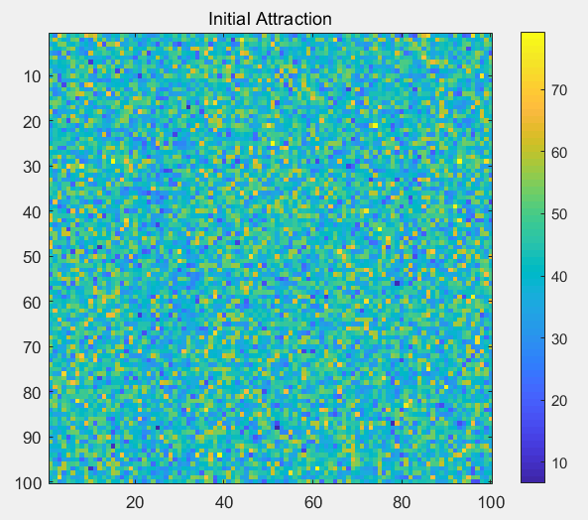

Fig 3.2.1

**3.3 蚯蚓在元胞中**

1. 为了尽可能真实地模拟蚯蚓的分布，我们将待处理土地简化为三维图形。我们将每个单元的初始值随机设置在0和80之间，细胞自动机初始状态时的蚯蚓分布如图3.3.1所示。
2. 细胞内所有蚯蚓都有一定的pmove概率迁移到附近的格(细胞)。蚯蚓更容易被“极具吸引力”的细胞所吸引，而远离“低吸引力”的细胞。因此，在细胞自动机进化后，蚯蚓的分布情况如图3.3.2所示。

**3.3 THE EARTHWORMS IN THE CELL**

1. In order to simulate the distribution of earthworms realistically, we abstracted the area into a three-dimensional figure. We randomly set the initial value of each cell between 0 and 80, and the initial distribution of the Cellular Automaton is shown as Fig 3. 3.1 below.

2. All earthworms in the cell have a certain probability of $P_{move}$ to migrate to the nearby cells. Earthworms are more likely to gravitate toward the "highly attractive" cells and stay away from the "lowly attractive" cells. Therefore, after the evolution of Cellular Automaton, the distribution of earthworms is shown as Fig 3.3.2 below.

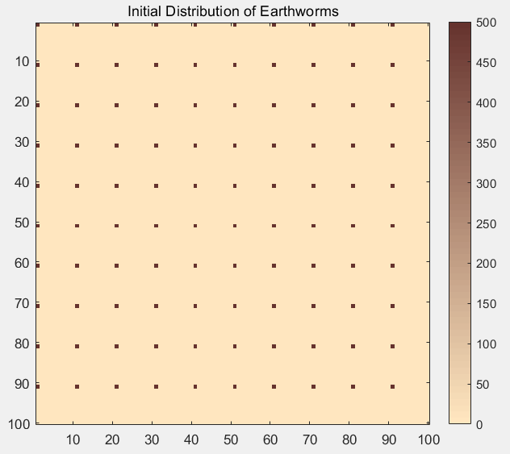

Fig 3.1.1

3.3.2的图

**4 模拟结果和分析**

基于上述模型设定，我们对各种蚯蚓投放方案进行了模拟分析，得到如图4.1的结果。

**4 SIMULATION RESULTS AND ANALYSIS**

Based on the above model setting, various earthworm feeding schemes were simulated and analyzed, and the results were obtained as shown in Figure 4.1.

各种结果图

**Reference**

[1] Ceccherini‐Silberstein T, Coornaert M. Cellular Automata and Groups[M]. 2010.

Download the source code (设置为链接)